MiniProject

# On

**Management Information System for Online Marriage Bureau**

***Submitted as a part of Course Curriculum***

## MastersofComputerApplications



**Submittedto: SubmittedBy:**

Dr. Gurpreet Singh Josan Ishika Garg (21071208),

Dr. Sukhjeet Kaur Ranade Shairya Sharma (21071225),

DepartmentofComputerScience Ssembuya Abdurahumani (21071291)

MCA (Semester - 2nd)(Sec-A)

## Department of Computer Science

## Punjabi University, Patiala

## 147002 Session (2021-2023)

**Candidate’sDeclaration**

We hereby declare that the Minor Project work being presented in this reportentitles **‘Management Information System for Online Marriage Bureau’** Submitted in the Department of Computer Science, Punjabi University, Patiala. It is Authentic Work carried out by me and my teammates under the guidance of **Dr. Gurpreet Singh Josan**, Asst. Prof DepartmentofComputerScience.

**Date _ _/__/_ ___** Ishika Garg **(21071208),**

Shairya Sharma **(21071225),**

Ssembuya Abdurahumani **(21071291)**

**DepartmentofComputerScience**

**Punjabi UniversityPatiala-147002(PB)**

# Acknowledgement

We would like to take this opportunity to express our gratitude to all those people without whom this project could have never been completed. First and foremostwe would like to express deep sense of thanks and gratitude to our mentor, teacher and guide **Dr.Gurpreet Singh Josan,** also He Helped us in doing a lot ofResearch and we came to know about so many new thing about this Project andwe’rereally thankfulto him.

Ishika Garg **(21071208),**

Shairya Sharma **(21071225),**

Ssembuya Abdurahumani **(21071291)**

Date:-__/__/____

# Abstract

The purpose of **Management Information System for Online Marriage Bureau** is to automate the existing manual system by the help of computerized equipments and full-fledged computer software, fulfilling their requirements, so that their valuable data/information can be stored for a longer period with easy accessing and manipulation of the same. The required software and hardware are easily available and easy to work with.

Online Matrimonial Site, as described above, can lead to error free, secure, reliable and fast management system. It can assist the user to concentrate on their other activities rather to concentrate on the record keeping. Thus it will help organization in better utilization of resources. The organization can maintain computerized records without redundant entries. That means that one need not be distracted by information that is not relevant, while being able to reach the information.

The aim is to automate its existing manual system by the help of computerized equipments and full-fledged computer software, fulfilling their requirements, so that their valuable data/information can be stored for a longer period with easy accessing and manipulation of the same. Basically the project describes how to manage for good performance and better services for the clients.

## TABLEOFCONTENTS

**SR.No CONTENTS PAGENo.**

### Introduction:

* 1. Purpose
  2. IntendedAudience
  3. Productscope 6-9
  4. Project Features
  5. Hardware/SoftwareRequirement
  6. Synopsis

### SystemDevelopment:

* 1. ProjectManagement
  2. SystemAnalysis AndDesign(DFD) 10-15
  3. SystemEnvironment

### DesignandImplementation:

* 1. DatabaseDesign
  2. SnapshotsOfSystem 16-24

### ProjectLegacy:

* 1. CurrentStatus
  2. ProblemsFaced 25
  3. Limitations
  4. FutureEnhancements
  5. Reference

## Introduction

**Purpose:**

The main purpose of this project is to build an application program to reduce the manual work for managing and accelerate the opportunities of providing newer matrimony services for sharing matrimonial information more comfortably and selectively, though often criticized in terms of adequacy and authenticity of such information.

Secured online matrimonial system is designed to overcome the drawbacks of existing system. It also provides fast searching for a life partner and sending his/her contact or communicates with the existing members. As both the members will agree they meet together for the marriage. A person can search for a bride or a groom of any religion of any caste.

## IntendedAudience:

Main intended audience of this system is maintained by user. User can perform many tasksat thetime like search for a bride/groom and if it seeks interest then it sends message.Sothe user can search profile but firstly have to register on that site. So, then it makes very difficult for the user to manage so many things at the same time, although oursystemhelps userto managethesethingsquiteefficiently.

## ProjectScope:

Scope of this project is to provide platform to a lot of Bride/Groom for finding perfect match. There are different sectors like Registration, Partner, Search, etc. So the Bride/Groom can get their interest for find their partner. Bride/Groom can directly search Partner according to their required criteria.

## ProjectFeatures:

**CROSSPLATFORMCOMPATIBILITY:-**OperatingSystemslikeWindows7, 8.1, 10, Linux are capable of running this project in their system. We can also use Oracle Database to run this.

**INTERACTIVITY:-**Interaction with the project is quite easy, and simple as the frontend design of the project is minimalistic an ergonomic approachis takenheretherefore anynewuserto it canuseit easily.

## Hardware/SoftwareRequirement:

* + 1. **HardwareRequirement:**

Memory: Minimum256MBRAMHardDiskSpace:8GB

Display: 14” LEDMonitor

## System Requirement:

OperatingSystem: Windows7or AboveFrontEnd:HTML,CSS,Bootstrap

Back End: PHP, Xampp ServerTextEditor: VisualStudioCode

Browser: GoogleChrome, MozillaFirefoxetc

# Synopsis

This project intends to use the latest advancements in technology in **Management Information System for Online Marriage Bureau**regardingmarriage and find perfect match. This application is to facilitate matchmaking business by applying the information in the field. It helps the user by providing profiles of Bride/Groom and other information regarding them online.

User can get information regarding their dream life partner at his/her home at his/her convenience. This application also provides a search utility which helps those users who have a certain criteria of qualities in mind to make online matrimonial easier. Since internet is a pivot for modern business, our project which is based on internet paves a path for modernization in trade.

Matrimonial Web Application will allow a new user to register and after successfully registration users profile will be visible to other users. Matrimonial website is providing platform to a lot of Bride/Groom for finding perfect match. There are different sectors like Registration, Partner, Search, etc. So the Bride/Groom can get their interest for find their partner. Bride/Groom can directly search Partner according to their required criteria.

# Benefits:

* Portability: The system is developed to work on any environment so it can be portable.
* Availability: This system will available on any system.
* User Interfaces: The software provides good graphical interface for the user any administrator can operate on the system, performing the required task such as create, update, and viewing the details of firms.

## 1.) Objective of the Project:

# The main objective of Matrimonial Web Application is to provide Grooms and Brides with excellent matchmaking experience by exploring the opportunities and resources to meet true potential partner. Keeping our objective in mind, we have created a world renowned online matchmaking services that will touch the souls of millions of people all over the globe.

# 2.) Project Category:

WebProject

# 3.)Structure of the Project:

### Functionality PerformedBythe User:

* + - Login
    - Register Profile
    - Partner Preferences
    - Find Bride/Groom

###  Functionality PerformedBythe Admin:

* + - Updating Login table and user table
    - Retrieve login table , user table , payments and

**SystemDevelopment**

* 1. **ProjectManagement:GantChart**

|  |  |  |  |  |  |  |  |  |  |  |  |  |
| --- | --- | --- | --- | --- | --- | --- | --- | --- | --- | --- | --- | --- |
| **PHASES** | **Day1** | **Day3** | **Day4-9** | **Day10-15** | | **Day16-25** | **Day21-30** | | **Day30-35** | | **Day36-41** | |
| **PLANNING** |  | |  | | | | | | | | | |
| **REQUIREMENTSANALYSIS** |  | |  |  | | | | | | | | |
| **DESIGN** |  | | |  | | |  | | | | | |
| **CODING** |  | | | |  | | | | | |  | |
| **TESTING** |  | | | | | | |  | | | |  |
| **IMPLEMENTATION** |  | | | | | | | | |  | | |

## DATA FLOW DIAGRAMS –

## 1. ZERO LEVEL

## 

## 2. LEVEL 1 DFD

## 

## 3. LEVEL 2 DFD

## 

## ERDiagram (Entity-RelationshipDiagram)

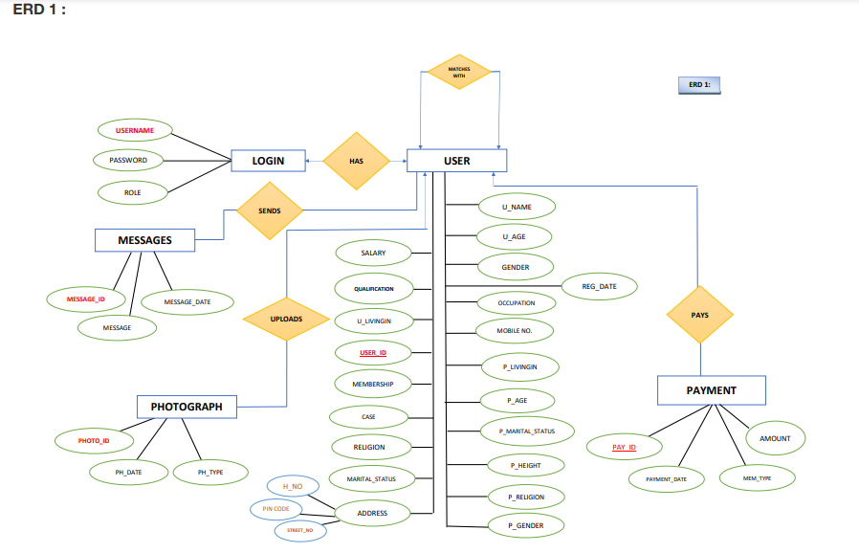

**ERD 2:**

*A*

*DVERTISER*



*ADVERTISE*

*ADVERTISEMENT*

***ADV_NAME***

***ADV_ID***

***DURATION***

***LOCATION***

*ADVT_ID*

**SystemEnvironment**

**IDE(IntegratedDevelopmentEnvironment)**

The IDE used to develop this project is Visual Studio Code which is developed by MicrosoftCorporation.Itisasourcecode editorhandyinperforming codingofvariousprogramminglanguages. VSC support for debugging, syntax highlighting, intelligent code completion,snippets, code refactoring, and embedded Git. Users can change the theme, keyboardshortcuts,preferences,andinstallextensionsthataddadditionalfunctionality.



## DatabaseUsed

Todevelopthisprojectweused ORACLEDATABASE18CEXPRESSEDITION.OurOracletutorialisdesigned for beginners and professionals. Our Oracle tutorial includes all topics of Oracledatabase such as insert record, update record, delete record, select record, create table, droptable etc. There are also given Oracle interview questions to help you better understand theoracledatabase.

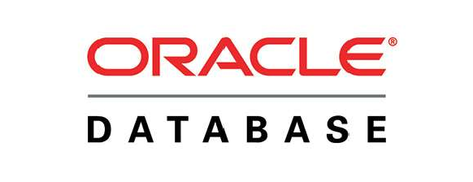

## 2.3.2BackEndProgrammingLanguage

As a back end programming language PHP is used in this project. PHP is an open-source,interpreted, and object-oriented scripting language that can be executed at the server-side.PHPiswellsuitedforwebdevelopment.Therefore,itisusedtodevelopwebapplications(anapplication thatexecutesontheserverandgeneratesthedynamicpage).

## DESIGNANDIMPLEMENTATION

**Relational Table: 1st Table:-**

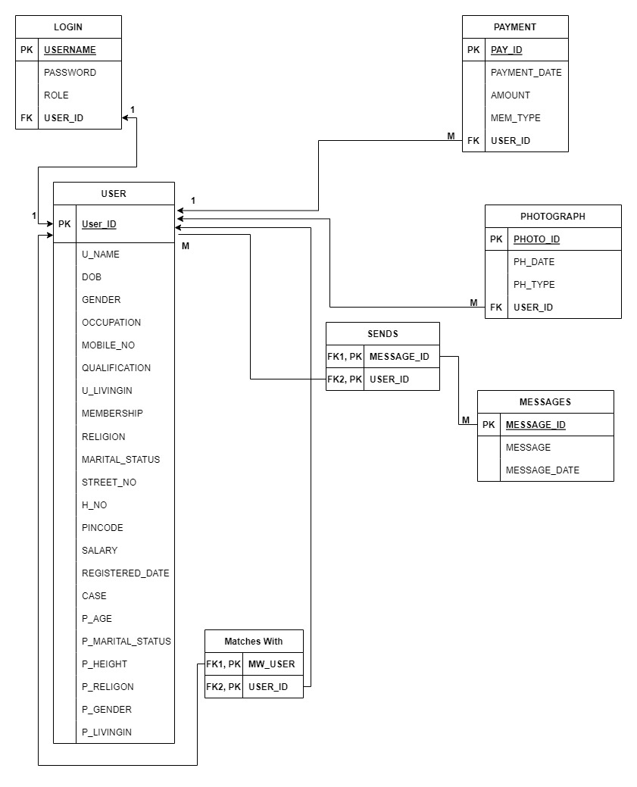

**2nd Table:-**

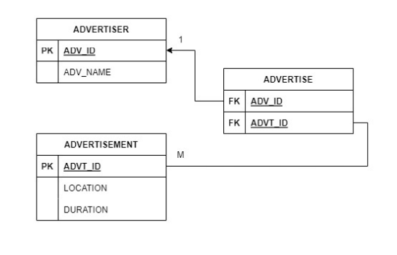

## SNAP SHOTS

## ADMIN:

## 

## 

## LOGIN AS ADMIN:

## 

## LOGIN TABLE DATA:-

## 

## MESSAGE TABLE DATA:-

## 

## USER TABLE DATA:-

## 

## 

## PAYMENT TABLE DATA:-

## 

## LOGIN AS USER:

## 

## AFTER SIGN UP: Home Page:-



About us:-

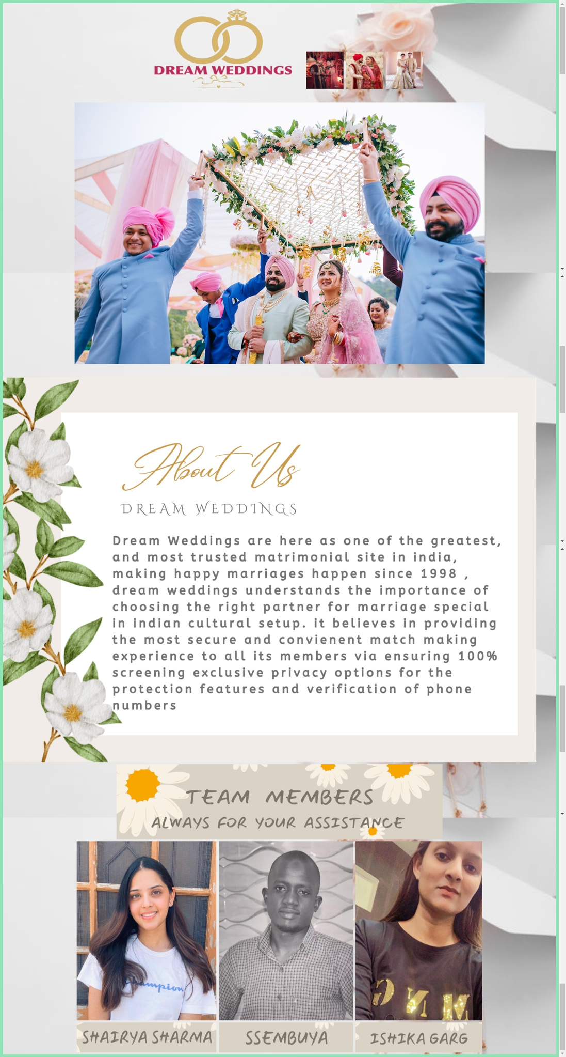

**Register:-**

* + 1. 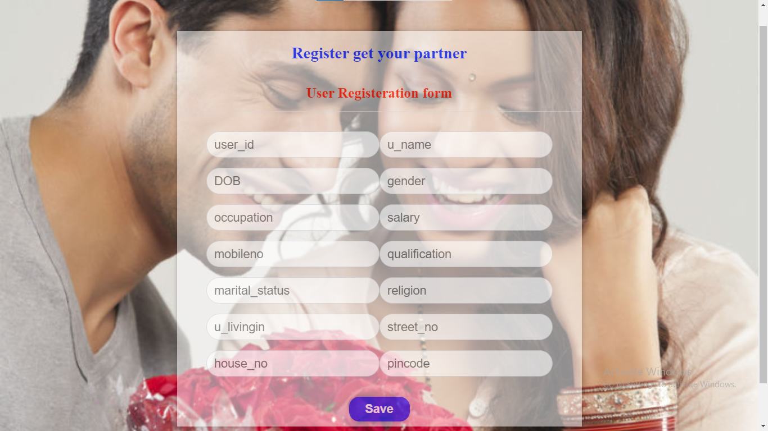

**Register Partner Preferences:-**

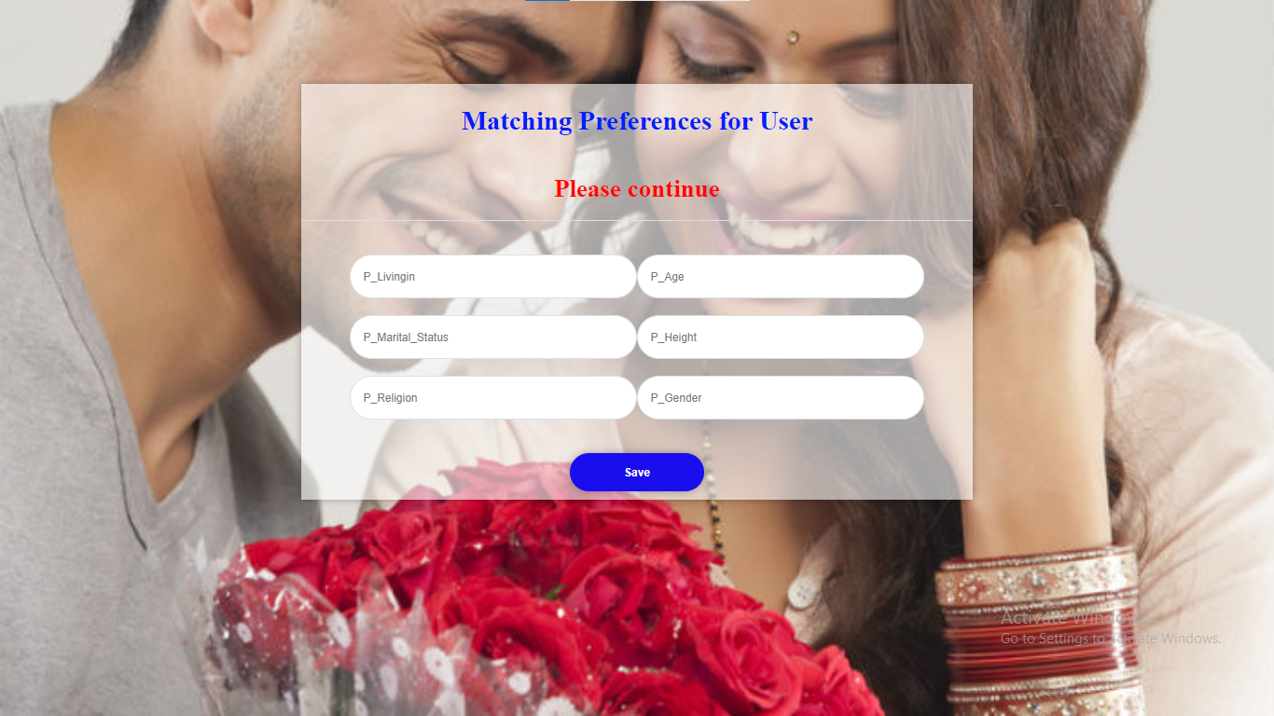**Bride Details:-**



**Groom Details:-**



## PROJECTLEGACY

**CURRENTSTATUS**

Projectiscompletedaspertherequirementspecification.Allfunctionsandoperationsthatarespecified is working properly. Currently Some Sales information is added to show thedemonstration of the project, similarly few transactions are also added in the project to showits working. And it is further possible to add more data to it and the project is capable ofhandlingalltheaddition/subtractionthatmaybedonetothisinthe future.

## PROBLEMFACED

ItisreallydifficulttoconnectOCI8withXAMPPserver, because to enable the connection this is the only way to connect oracle with Php, hence viewing all the tutorials we’ve been able toconnectourdatabase.

## LIMITATIONS

Till now there are only messages available, further we can give access to video chat or access of any other platforms for furtherreference.

## FUTUREENHANCEMENT

In future multiple enhancements can be bringing to this project; in future we can introduce new things to add in this project.

## CONCLUSION

Thisprojectisbasicallyto find the perfect potential partner.

## Reference

**https://**[**www.w3schools.com/sql/**](http://www.w3schools.com/sql/)

**https://**[**www.geeksforgeeks.org/bootstrap-tutorials/**](http://www.geeksforgeeks.org/bootstrap-tutorials/)

**https://**[**www.codewithharry.com/**](http://www.codewithharry.com/)**php**